1. **Title of the document**

Performance Analysis of Tunnel Field-Effect Transistors

1. **Identification**

SATYABRAT SAHOO -1541016245

DEBATANAYA SATPATHY -1541016365 SAMBIT SENAPATI-1541016260

1. **Abstract**

For more than five decades, the miniaturization of circuits, achieved by the scaling down of metal-oxide field- effect transistors (MOSFETs), has been the principle driver for the semiconductor industry.However, the stringent power constraints of integrated circuits and the non-scalability of the substhrehold slope in a conventional MOSFET, now pose a serious threat to the continued scaling of field-effect transistor.Therefore,intensive research is being carried out on novel steep subthreshold-slope devices that can be replaced the conventional MOSFET in future integrated circuits.Hence,Tunnel Field Effect Transistors (TFETs) are very promising devices as they exhibit a substhreshold swing lower than 60Mv/decade,which is the theoritical limit for a conventional MOSFET.Consequently, TFET-based circuits can be highly energy efficient .

An exhaustive research of TFETs was triggered around 2004 with the successful demonstration of the substhreshold swing below 60mV/decade and the necessity for a device that can replace conventional MOSFETs for low-power energy-efficient circuits.Since,then there has been a thorough investigation of various aspects of TFETs and their applications in integrated circuits.The number of research papers on TFETs has been growing exponentially.

# List of Figures

Fig.no. Figure Caption Page

1. Basic TFET Structure 6
2. Simple implementation of a TFET and

the biasing scheme 7

1. Band diagram of an n-type TFET in the

OFF-state and in the ON-state 8

1. Band diagram of an p-type TFET in the

OFF-state and in the ON-state 10

1. Simulated transfer characteristics of the

TFET at VDS= 1V 11

1. Silicon on insulator tunnel field –effect

Transistor 12

1. Transfer characteristics of the DGTFET with the same doping on the source and

the drain 15

# Introduction

AS MOSFETs are scaled down, the power supply voltage should also go down in order to reduce power density. For example, a 45-nm low-operating-power devices should have a power supply voltage of 0.9 V . In order to maintain a high ON-state current with an acceptable OFF-state leakage, a reduction of the subthreshold swing (SS) is necessary and has emerged as one of the most important technological issues. However, even in the ideal case of inﬁnite gate capacitance, the SS of MOSFETs cannot be reduced below 60 mV/dec at room temperature. Some novel devices have been proposed to achieve a sub-60- mV/dec SS such as impact-ionization MOS devices, nanoelectromechanical FETs, suspended gate MOSFETs

, and tunneling FETs (TFETs). Among them, this report focuses on the TFET. The TFET is merely a gated p-i-n diode operating under reverse bias, . Unlike the MOSFET which uses thermal carrier injection, the TFET utilizes band-to-band tunneling as a source carrier injection mechanism.

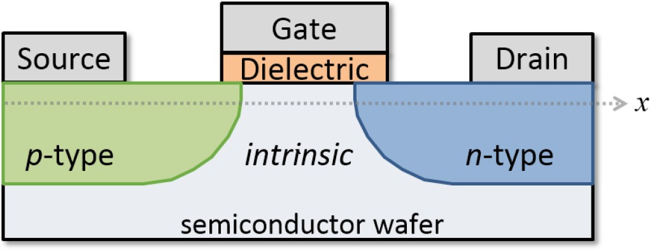

# FIGURE 1

Basic TFET structure [1].

# Methodology

DEVICE STRUCTURE

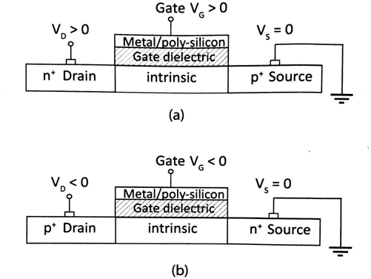

# F IGURE 2

A simple implementation of a TFET and the biasing scheme: (a) n-type TFET

1. p-type TFET [1].

In simple terms, the TFET is a gated reverse bias p-i-n structure. A simple implementation of a n-type and p-type TFET is shown in above figure. Structurally, the most distinguishing feature of a TFET is the type of doping of the drain and the source. The doping of drain and the source are of opposite types in a TFET. In contrast, the drain and the source doping are of the same type in a conventional MOSFET. For an n-type of TFET, the drain is doped n+ while the source is doped p+. For a p-type TFET, the drain is doped p+ while the source is doped n+. The channel is an intrinsic or lowly doped p-type or n-type

semiconductor. The channel is separated from the gate electrode by a dielectric, similar to a conventional MOSFET.

The biasing schemes of an n-type and a p-type TFET are shown in figure. For an n-type TFET, the source is grounded and a positive voltage is applied to the drain and the gate electrodes. For p-type TFET, the source is grounded and a negative voltage is applied to the drain and the gate electrodes. A TFET is called an n-type TFET or a p-type TFET depending on the dominant carrier in the channel formed under the gate when the TFET is turned on. When the dominant carriers in the channel are electrons, the TFET is called an n-type TFET and when the dominant carriers in the channels are holes, the TFET is called p-type TFET. The terminals are called source or drain depending on whether the dominant carriers enter or leave the channel through that terminal. The mechanism of the dominant carriers entering the channel is band-to-band tunnelling (BTBT).

DEVICE OPERATION

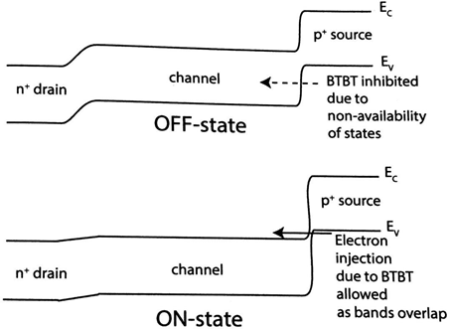

**FIGURE 3**: Band diagram of an n-type TFET in the OFF-state and in the ON-state [1].

The operation of a TFET is based on band-to-band tunnelling (BTBT). BTBT involves tunnelling of carriers from the valence band into the conduction band through the forbidden band gap or viceversa.

Band diagrams of an n-type TFET are shown in figure in the OFF-state and in the ON –state. When the gate voltage is close to zero, the TFET is in the OFF- state. The conduction band in the channel lies above the valence band in the source. As a result, BTBT is inhibited and the TFET is in the OFF-state with extremely low drain current. When gate voltage is increased, the gate voltage modulates the carrier density below the gate and the conduction band in the channel pushed down. When sufficiently high voltage is applied to the gate, there is band bending at the source such that the valence band in the source and the conduction band in the channel get aligned, as shown in figure. As a result, the electrons in the valence band in the source can tunnel to the conduction band in the channel. The electrons that tunnel into the channel are swept to the drain terminal by the positive bias of the drain. This forms the basics of operation for an n-type TFET.

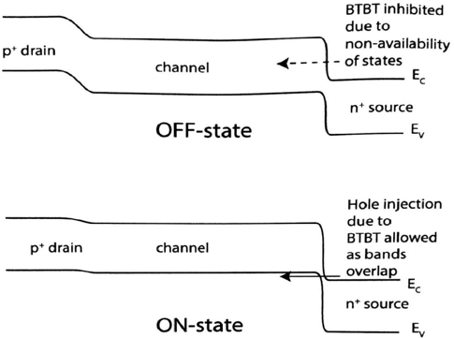

**FIGURE 4:** Band diagram of a p-type TFET in the OFF-state and in the ON-state [1].

The band diagrams of a p-type TFET are shown figure in the OFF-state and in the ON-state. The principle of operation of a p-type TFET is similar to the n- type TFET. When the gate voltage is close to zero, the TFET is in the OFF- state. When sufficiently large negative voltage is applied to the gate, the valence band in the channel is pushed above the conduction band in the source as shown in figure. As a result, holes are injected into the channel, which are subsequently swept to the drain terminal by the negative bias of the drain. This forms the basis of operation for a p-type TFET.

TRANSFER CHARACTERISTICS OF TFET

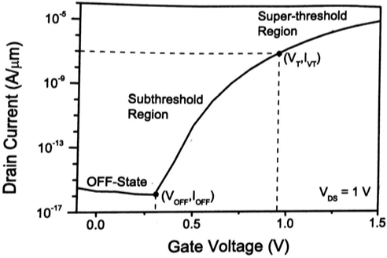

**FIGURE 5:** Simulated transfer characteristics of the TFET at VDS= 1V [9].

Figure shows the simulated transfer characteristics of the TFET at VDS= 1 V, obtained by sweeping the gate voltage from VGS= -0.1 V to VGS = 1.5 V. In general, we can divide the transfer characteristics of a TFET into three regions:

* 1. OFF-state (0 < VGS < VOFF) : In this region the TFET has an extremely low current and BTBT is inhibited. VOFF is the gate voltage at which the drain current starts to take off.
  2. Subthreshold region ( VOFF < VGS < VT) : In this region the drain current rises rapidly. VT is the threshold voltage of the TFET.
  3. Super-threshold region ( VGS < VT) : In this region the drain current rises with the gate voltage at a reduced rate.

DIFFERENT TYPES OF TFETs

TFETs have been proposed and realized in various structural forms. On the basis of the gate structure in the TFET, the TFETs can be classified as single- gate TFET, double-gate TFET, or gate-all-around TFET. The double-gate- TFET and gate-all-around TFET have better control over the channel potential compared to a single-gate TFET. TFETs have been realized with a homojunction at the source and a heterojunction at the source. The heterojunction TFET achieves a much lower effective bandgap than a homojunction TFET [3]. Additionally, different semiconducting materials like silicon, Germanium, Carbon and III-V semiconductor materials have been incorporated into the TFETs. Materials like nanowires, CNTs and graphene that exhibit quantum confinement effects are also being investigated for TFETs. These material have special properties that can be exploited to improve the electrical characteristics of the TFETs.

# Results & Discussions

IMPACT OF DEVICE PARAMETERS

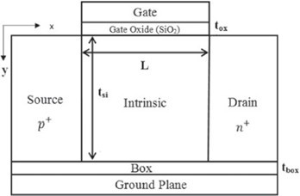

**FIGURE 6:** Silicon on insulator tunnel field-effect transistor [2].

# GATE DIELECTRIC

The drain current is expected to increase with an increase in dielectric constant of the gate material or decrease in gate dielectric thickness. It has been widely analyzed an experimentally verified that the tighter gate control obtained by employing a high-*k* dielectric material or decreasing the gate dielectric thickness results in increasing the ION of the TFET.

# BODY THICKNESS

The impact of the silicon body thickness on the drain current depends on two competing effects

. As the silicon body thickness increases, the volume of silicon available for BTBT increases, thereby increasing the drain current. However, as the thickness of the silicon body increases, the coupling of the gate with the channel degrades, leading to a decrease in drain current.

# SOURCE DOPING CONCENTRATION AND PROFILE

When the source doping concentration is increased, the band gap narrowing increases, which results in a decrease in the tunnelling distance. For high source doping concentration, due to the modified built-in potential at the source- channel junction, the threshold voltage is expected to reduce.The tunnelling current also depends on the abruptness of the source doping profile. With increase in the abruptness of the source doping, the electric field at the source- channel junction increases, resulting in an increase in the tunnelling current.

# CHANNEL LENGTH

The tunnelling current depends primarily on the electric fields and the band alignment near the source-channel junction, the tunnelling current does not change much with decrease on the channel length.

AMBIPOLAR CURRENT

There are two tunneling junctions in TFET : the source-channel tunneling junction and the drain-channel tunneling junction. Normally, the BTBT in the drain channel junction is suppressed in a TFET by reducing the drain dopping or using some other technique. However, when the TFET is symmetric, i.e. , the same doping concentration but of opposite type is used on the source side and on the drain side, then the TFET exhibits ambipolar behaviour. Ambipolar behaviour means that the same TFET shows n-type behaviour with the electrons making the major contribution in current transportand a p-type behaviour with the holes making the major contribution in the current transport, at the same drain voltage VD. An n-type TFET can conduct for the positive VG with BTBT on the source side and for the negative VG with BTBT on the drain side , keeping the VD positive. Similarlly, a p-type TFET can conduct for the negative VG with BTBT on the source side and for the positive VG with BTBT on the drain side, keeping the VD negative.

MINIMIZATION OF AMBIPOLAR CURRENT

1. Reducing drain doping.
2. Creating a drain-gate underlap.
3. Employing a heterojunction.
4. Introducing some kind of asymmetry into the TFET structure.

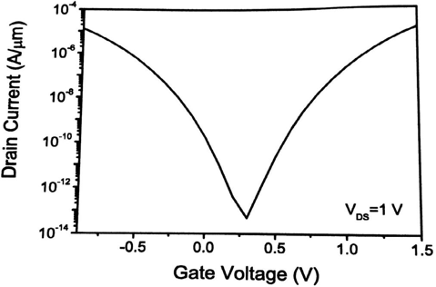

**FIGURE 7:** Transfer Characteristics of the DGTFET with the same doping on the source and the drain [9].

Figure the transfer characteristics of a TFET that has the same doping concentration for the source and the drain. When VG is positive, the conduction band and valence band get aligned on the source side, as in the normal n-type mode of operation of TFET. However when VG is negative, the bands get aligned on the drain side, resulting BTBT on the drain side.

TEMPERATURE DEPENDENCE OF TUNNELING FETS

The temperature and voltage dependence of the GIDL effect in MOSFETs under low electric field is investigated. The dependency of the GIDL current on the electric field E can be expressed as

IGIDL α AE5/2 exp (-B/E)

The parameter are given by A ∝ E -7/4 Gand B ∝ E 3/2, wGith the band-gap energy EG. From Eqn. the GIDL current is derived to be very weak dependent on the temperature. However a second effect exists at low electric field. Under low electric field the GIDL current can be described by the Shockley-Read-Hall (SRH) model, which has strong temperature dependence. Under higher electric field the GIDL current is dominated by Band-to-Band tunneling which has weak temperature dependence. Due to the comparable physical principle of the GIDL current and the TFET, Eqn. can be used to separate the SRH part of the TFET characteristic from the Band-to-Band tunneling part. Hence, starting from a gate-to-source voltage of approximately -1V the Band-to-Band tunneling is the dominant mechanism. Like for the MOSFET the temperature dependency is changing with the voltage applied. For the MOSFET the zero temperature coefficient point can be used for digital circuit design to make the system performance independent of the temperature. For the TFET the voltage where the change of the temperature dependence occurs is outside the useable range. Hence, the combination of the MOSFET and the TFET can be used to compensate for temperature effects. For analog circuits the temperature dependence has to be verified in more detail. Obviously, the temperature effect of the TFET is more comparable to the bipolar device [10].

APPLICATIONS OF TFET

TFET or tunnel FETS are similar to MOSFETs and applications of these two are similar like a digital switch, etc. The working principle of TFETs is quite different than MOSFETs. In MOSFETs, the flow of current will be due to diffusion phenomenon, while in Tunnel FETs, the conduction mechanism is allied to Zener Tunneling.

The TFET belongs to the family of so-called steep slope devices that are presently being examined for ultra-low-power electronic applications, Because of their low-off currents, they are perfectly suitable for low-standby-power logic and low-power applications which are functioning at moderate frequencies. Other applications of tunnel FETS include ultra low- power specific analog ICs (integrated circuits) with better temperature strength and low-power SRAM.

The main advantages of TFETs include the following:

* Having Less SS<60 mV/decade.
* Low power requirement.

# Conclusion

TFET are one of the most promising exploratory devices since they exhibit a subthreshold swing lower than 60mv/decade which is a theoritical limit for a conventional MOSFET at room temperature. TFET based circuits can be highly energy-efficient and TFETs are often regarded as “**green transistor**”.

# Reference

1. M.R. William and A.J. A. Gehan, “Silicon surface tunnel transistor.” Appl. Phys. Lett. **67**, 496 (1995)
2. H. Holonyak, Jr. *et al.*, "Impact of device parameter on soi TFET." Phys. Rev. Lett. **3**, 167 (1959).
3. B. Ganjipour *et al.*, "Tunnel Field-ffect Transistors Based on InP-GaAs Heterostructure Nanowires," ACS Nano **6**, 3109 (2012).
4. W. Y. Choi *et al.*, "Tunneling Field effect Transistors (TFETs) with Subthreshold Swing (SS) Less Than 60 mV/dec", IEEE Electron Device Lett. **28**, 743 (2007).
5. J. I. Pankove, *Optical Processes in Semiconductors* (Dover, 2010).
6. P.F. Wang *et al.*, "Complementary Tunneling Transistor for Low Power Applications," Solid State Electron. **48**, 2881 (2004).
7. Q. Zhang, W. Zhao and A. Seabaugh, "Low-Subthreshold-Swing Tunnel Transistors," IEEE Electron Device Lett. **27**, 297 (2006).
8. A. M. Ionescu and H. Riel, "Tunnel Field-Effect Transistors as Energy- Efficient Electronic Switches", Nature **479**, 329 (2011).
9. F. Balestra *et al.*, "Double-Gate Silicon-on-Insulator Transistor With Volume Inversion: A New Device With Greatly Enhanced Performance," IEEE Electron Device Lett. **8**, 410 (1987).
10. T. Nirschi *et al.*, "The Tunneling Field Effect Transistor (TFET): The Temperature Dependence, the Simulation Model, and Its Application," Proc. Intl. Symp. on Circuits and Systems ICAS **3**, 713 (2004).